**Spring WebFlux OpenAPI 3 | Swagger Documents for WebFlux Functional Programming Model**

**--------------------------------------------------------------------------------------------------------------------------------**

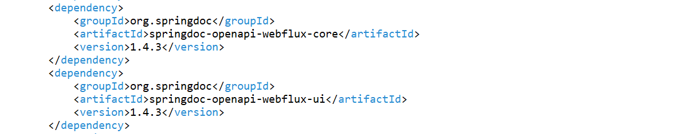

------------------------------------------------------------------------------------------------------------------------------------------

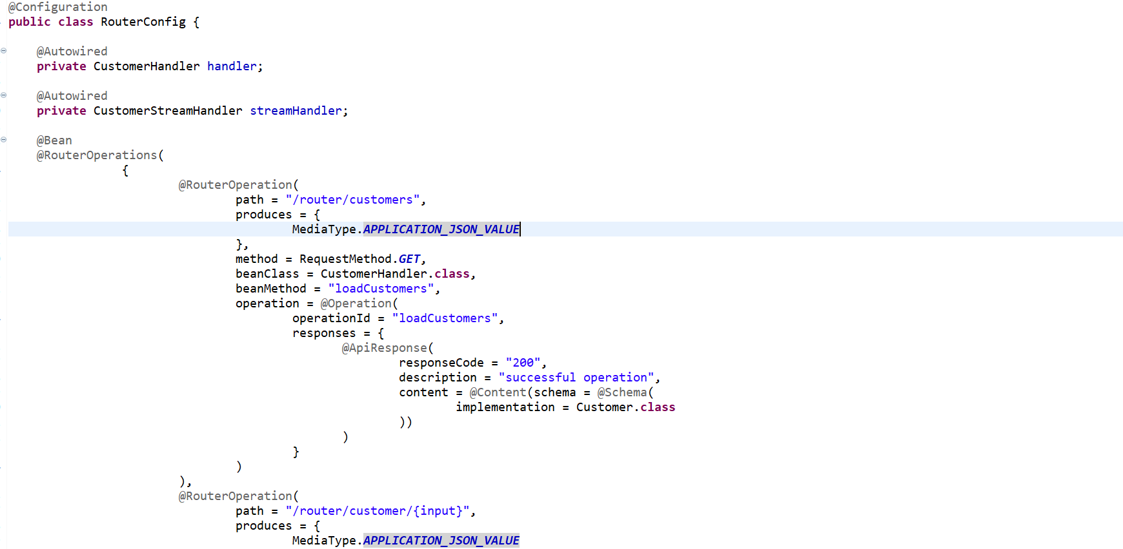

------------------------------------------------------------------------------------------------------------------------------------------

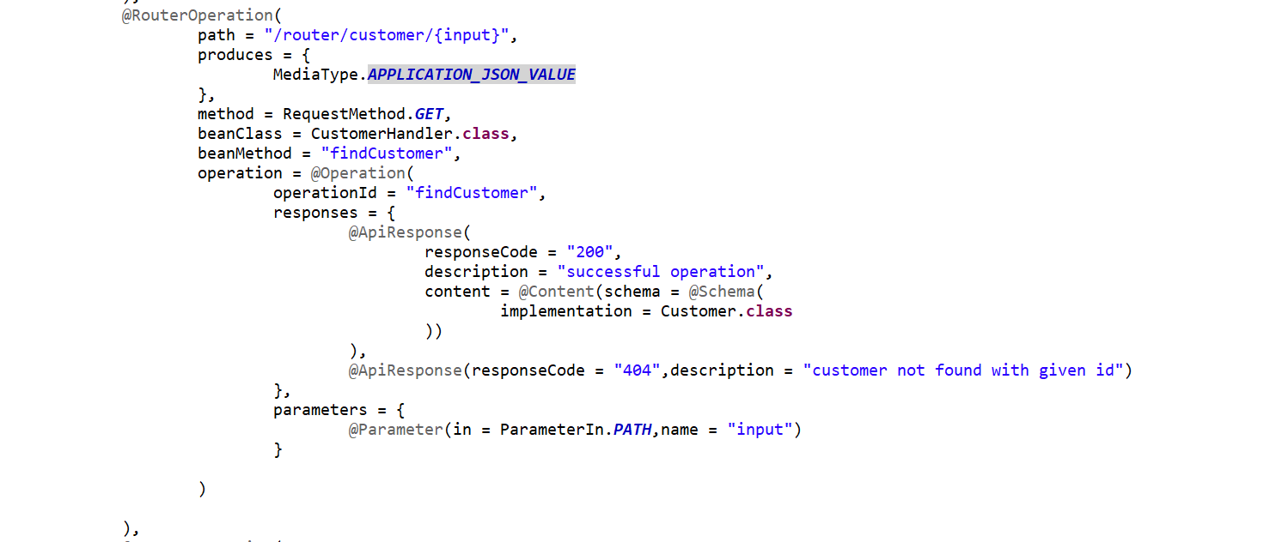

**Name App - springboot-webflux-demo**

------------------------------------------------------------------------------------------------------------------------------------------

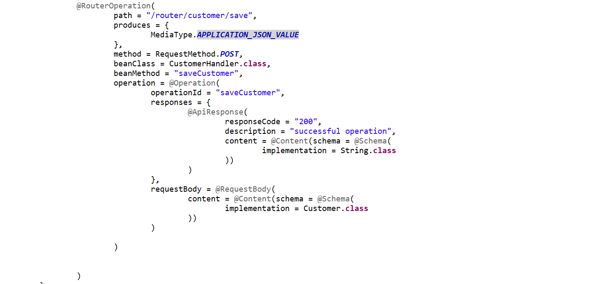

------------------------------------------------------------------------------------------------------------------------------------------

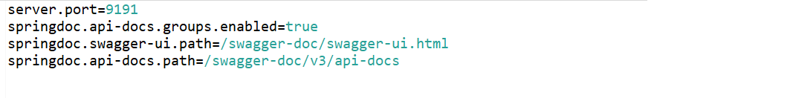

------------------------------------------------------------------------------------------------------------------------------------------

Now let’s start and run our application

<http://localhost:9191/swagger-doc/swagger-ui.html>

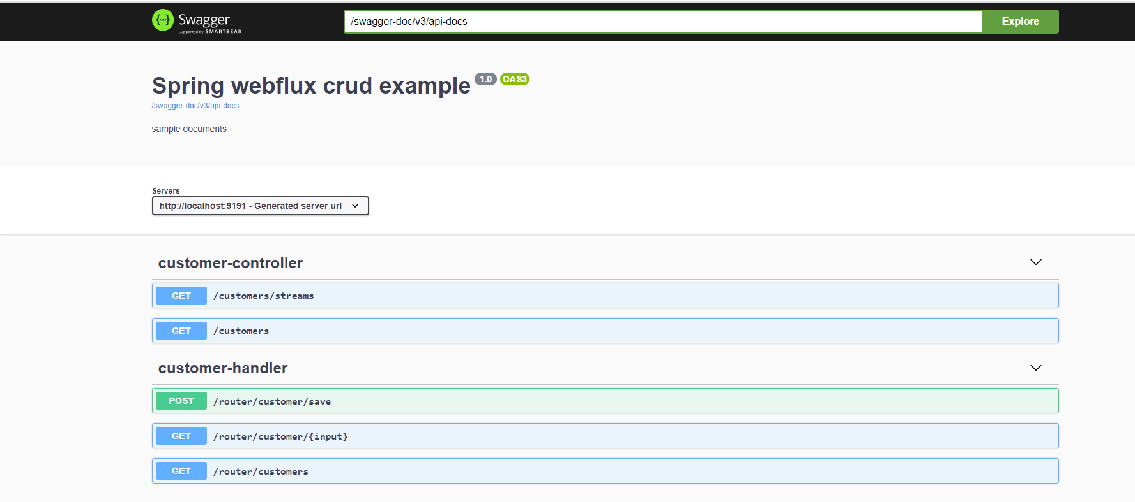

<http://localhost:9191/swagger-doc/v3/api-docs>

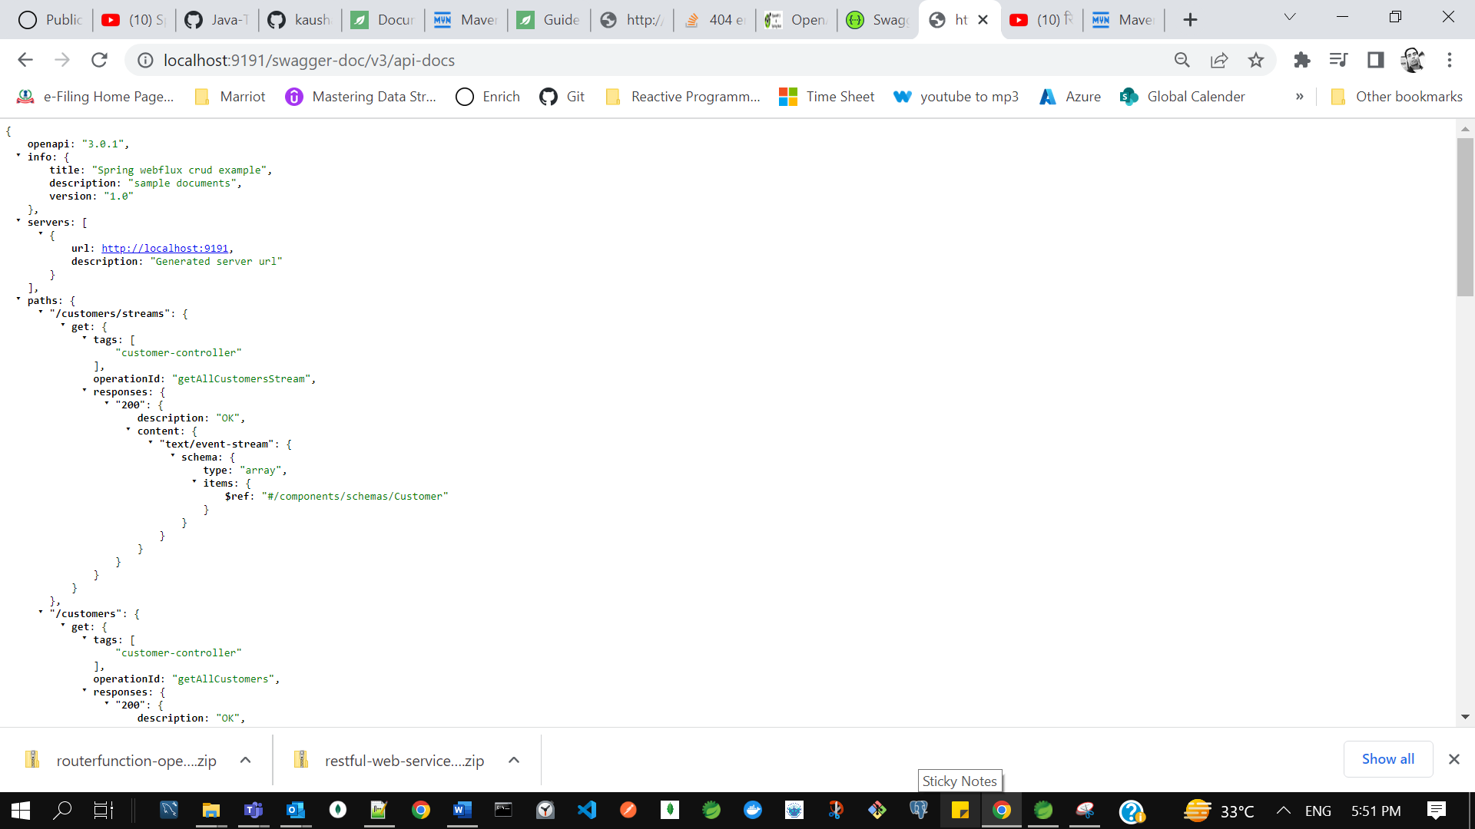

this is how you can generate the Sago documentation for functional style of your programming and now if you let me show the API docs for it just copy this go to the browser type localhost 9191 then just add it this is what the API documentation your requirement from scratch you can write this open API documentation that is what the first API design approach there is something the terminology is like for a open API you can use that okay so let me know in comment section if you want to start your development from this Swagger open API we will take a scenario and we'll start writing the API docs for it then we'll import and generate the spring boot project